 | SIMATS ENGINEERING  Department of Computer Science and Engineering
CSA15 Cloud Computing and Big Data Analytics
CO4 AT2 - Big Data Industry Problem Solving Guided Tool Workbook
Course Code | CSA15 | Slot | C
Assessment | CO4 AT2 | Bloom Level | BL4 - Analyze
Faculty | Dr C. Rajesh Babu | Employee ID | SSETSCS415
Mode | Individual guided tool-based workbook | Submission | GitHub repository link through Google Classroom
End Evidence | Workbook + screenshots + diagrams + dashboard/mockup | Marks | 30

Student Details
Student Name | K DHEEPAK | Register Number | 192411108
Class / Section | CSA1517 | Slot | C
Selected Scenario | Cybersecurity Threat Monitoring | Submission Date | 03/09/2026
GitHub Link |  | Google Classroom Status

Workbook Purpose
What this workbook does
This workbook guides students to use real software tools and official technical references to derive a big-data industry solution. Students should learn from the tool, observe patterns, record evidence and then write their own technical explanation.
- Do not copy full text from websites or AI tools.
- Use official references to justify architecture, processing and security decisions.
- Screenshots are evidence; explanations are the actual assessment answer.

Scenario Bank
Instruction
Faculty may assign one scenario or ask students to complete more than one. If no specific scenario is assigned, select one scenario and complete all tool-guided sections for that scenario.
No. | Scenario | Data Context
1 | Healthcare Emergency Analytics | Emergency department data, ambulance updates, bed availability, alerts and treatment delays.
2 | E-Commerce Customer Behavior Intelligence | Clickstream events, cart abandonment, payment failure, campaign traffic and recommendation impact.
3 | Smart Agriculture Advisory Platform | Weather, soil sensors, crop advisories, pest reports, market prices and farmer app interactions.
4 | Cybersecurity Threat Monitoring | Authentication logs, firewall alerts, API access logs, failed login attempts and suspicious network events.
5 | Public Transport Demand Analytics | Ticketing data, bus GPS, passenger count, route delay, peak-hour demand and crowding alerts.

Selected Scenario and Reason
Selected Scenario: Cybersecurity Threat Monitoring.
Reason: My capstone, CrowdCare, ingests continuous sensor and incident data and must detect anomalies in near real time, which maps directly onto this scenario's authentication logs, firewall alerts, API access logs, failed logins and suspicious network events.
This scenario lets me reuse the same ingestion -> stream processing -> analytics -> alerting pattern that CrowdCare needs for crowd-density anomaly and incident alerts.
Working through cloud security architecture and threat modeling tools here directly strengthens the security layer of my own capstone.

Guided Tool Module 1: Use Cloud Architecture Centers
Purpose: Use official cloud architecture references to identify suitable ingestion, storage, processing, analytics and security components for the selected scenario.
No. | Perform |  | Observe / Decide |  | Record in Workbook
1 | Open AWS Architecture Center, Azure Architecture Center and Google Cloud Architecture Center in three browser tabs. |  | You are not copying a full architecture. You are learning common cloud patterns and service categories. |  | Paste the three page titles or URLs.
2 | Search each site using terms from your scenario, such as healthcare analytics, streaming analytics, data lake, retail analytics, IoT analytics or security monitoring. |  | Notice which patterns repeatedly appear: ingestion, data lake, warehouse, processing, ML/analytics, visualization and security. |  | Record at least one useful reference from each cloud provider.
3 | Identify the services/components mentioned in the reference diagrams. |  | Separate service category from vendor-specific service name. Example: object storage is the category; Amazon S3/Azure Blob Storage/Cloud Storage are service examples. |  | Complete the tool-category table.
4 | Compare the three references. |  | Choose the most suitable architecture pattern for your scenario and explain why. |  | Write a short justification.
5 | Draw your own provider-neutral architecture in draw.io. |  | Your diagram must show data sources -> ingestion -> storage -> processing -> analytics/dashboard -> users, with security controls. |  | Paste the diagram screenshot/link.
Cloud Provider |  | Reference Page / URL |  | Useful Pattern Found |  | Useful Service Categories
AWS |  | aws.amazon.com/architecture/security-threat-monitoring |  | Centralized log ingestion feeding a SIEM with automated incident response |  | Log ingestion, threat detection (GuardDuty-type), SIEM/analytics, automated response
Azure |  | learn.microsoft.com/en-us/azure/architecture (Cybersecurity Threat Monitoring) |  | Data sources feed ingestion, landing in storage/analytics before SIEM correlation and automated playbooks |  | Log/event ingestion, data lake storage, SIEM, automation/playbook response, visualization
GCP |  | Google Cloud Architecture Center (security monitoring reference) |  | Managed compute/storage/functions monitored centrally with a project-level dashboard |  | Compute monitoring, managed storage, serverless functions, centralized project dashboard

Cloud Architecture Justification
Across AWS, Azure and GCP reference architectures, a common pattern emerges: logs and events are ingested through a managed ingestion layer, streamed through a processing/analytics service, stored in both a fast lookup layer and long-term storage, and surfaced through a SIEM/dashboard with automated alerting.
For a cybersecurity monitoring workload a streaming-first architecture is better than a pure batch pipeline, because failed logins, firewall alerts and suspicious network events need near real-time correlation to be useful.
Ingestion: a managed event/log ingestion service (Kinesis Data Firehose / Event Hubs / Pub-Sub category) collects logs from firewalls, auth systems and APIs.
Processing and storage: a stream-processing engine enriches and filters events, writing raw logs to cheap object storage and processed/aggregated results to a fast analytics store.
Security and analytics: a SIEM-style service correlates events against threat-intelligence feeds, and a dashboard/alerting layer notifies a security analyst of high-risk incidents.

Architecture Diagram Evidence
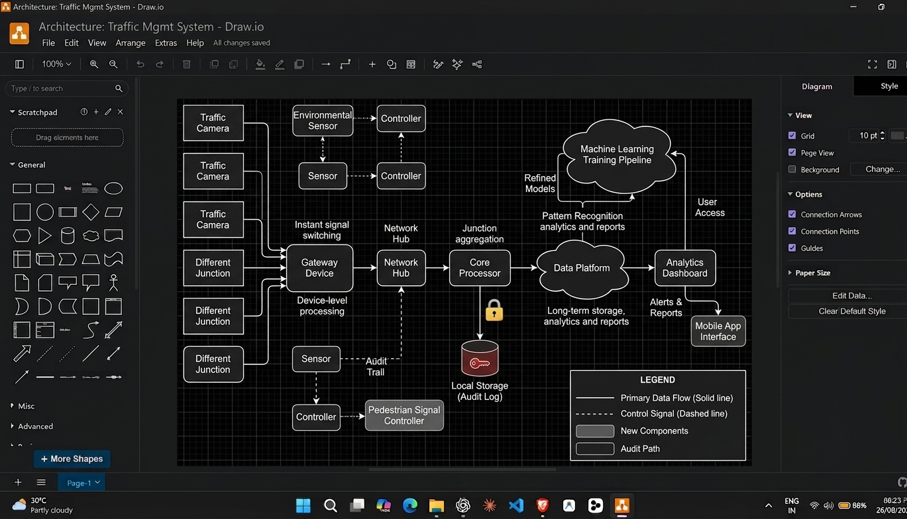

Guided Tool Module 2: Use Hadoop and Spark Documentation
Purpose: Decide whether your problem needs batch processing, streaming processing or hybrid processing by reading official Hadoop/Spark documentation.
No. | Perform |  | Observe / Decide |  | Record in Workbook
1 | Open the Apache Hadoop MapReduce tutorial. |  | MapReduce is suitable when large stored data can be processed in batches, such as daily logs or historical transactions. |  | Write one sentence on what mapper and reducer mean.
2 | Open the Apache Spark Structured Streaming guide. |  | Structured Streaming is suitable when new events continuously arrive, such as sensors, clickstream, live alerts or location updates. |  | Write one sentence on what streaming source, processing and sink mean.
3 | Classify your scenario data into batch data and streaming data. |  | Historical records normally become batch data; live sensor/log/API updates normally become streaming data. |  | Complete the batch-vs-stream table.
4 | Choose one processing approach for your scenario: Hadoop/MapReduce, Spark batch, Spark streaming or hybrid. |  | The decision must match the data velocity and decision urgency. |  | Write your processing decision.
5 | Prepare a simple pseudo-flow, not full code. |  | Example: Mapper reads log line -> emits hour, count. Reducer sums counts. Dashboard shows peak hour. |  | Write pseudo-flow or paste diagram.
Data Item |  | Batch / Streaming |  | Why |  | Suggested Framework
Authentication logs |  | Streaming |  | Failed/successful logins must be checked for brute-force patterns within minutes |  | Spark Structured Streaming
Firewall alerts |  | Streaming |  | Active network threats need near real-time blocking decisions |  | Spark Structured Streaming
API access logs |  | Hybrid |  | Live anomaly checks matter, but full pattern audits are done over longer windows |  | Spark Streaming + nightly Hadoop batch job
Failed login attempts |  | Streaming |  | Credential-stuffing attacks must trigger an alert within seconds to minutes |  | Spark Structured Streaming
Suspicious network events |  | Batch |  | Deep correlation against months of history is more valuable than instant flagging alone |  | Hadoop/MapReduce batch analysis
Historical incident archive |  | Batch |  | Used for trend reports and model retraining, not time-critical |  | Hadoop/MapReduce batch analysis

Processing Framework Decision
Decision: Hybrid processing - Spark Structured Streaming for real-time detection, with periodic Hadoop/MapReduce-style batch jobs for historical trend analysis.
Authentication logs, firewall alerts, API access logs and failed-login attempts arrive continuously and need sub-minute detection, so they are handled as a streaming source.
Suspicious network events that need deeper historical correlation (e.g. comparing this week's pattern against the last 90 days) are better handled as a nightly batch job over data lake storage.
Streaming gives low-latency alerts for active attacks; batch gives cheaper, thorough analysis for trend reports and model retraining.
This mirrors the hybrid pattern seen in the cloud reference architectures: a hot streaming path plus a cold storage/batch path feeding the same analytics store.

MapReduce / Spark Pseudo-Flow
Mapper/Reducer, one sentence: the Mapper reads each raw log line and emits a key (e.g. source IP) with a count of 1; the Reducer sums all counts per key to produce an aggregated event-frequency table.
Streaming source/processing/sink, one sentence: the streaming source continuously receives new log events, the processing step filters/enriches and windows them, and the sink writes results to a dashboard or alert queue.
Batch pseudo-flow: Mapper reads log line -> emits (source_ip, 1) -> Reducer sums counts per source_ip -> output shows top offending IPs over the last 24 hours.
Streaming pseudo-flow: stream source (auth/firewall logs) -> filter for failed-login/suspicious-event types -> 1-minute tumbling window count per user/IP -> sink writes rows above threshold to the alert dashboard.
The streaming path answers 'is an attack happening right now'; the batch path answers 'what changed over the last week'.

Guided Tool Module 3: Threat Modeling with OWASP Threat Dragon / Microsoft Tool
Purpose: Identify privacy and security risks in the big-data solution before proposing controls.
Tool Choice
Use OWASP Threat Dragon if you need a web/desktop cross-platform threat modeling tool. Use Microsoft Threat Modeling Tool when a Windows system is available. The required evidence is the threat model diagram and threat-control table.
No. | Perform |  | Observe / Decide |  | Record in Workbook
1 | Open OWASP Threat Dragon or Microsoft Threat Modeling Tool. |  | A threat model is a security diagram that shows components, data flows, trust boundaries and possible threats. |  | Write which tool you used.
2 | Create a new threat model named with your scenario. |  | Use a clear title such as CO4_AT2_Healthcare_Emergency_Analytics. |  | Paste model name.
3 | Add external entities. |  | External entities are users/systems outside your platform: patient, customer, sensor, payment gateway, bus GPS device, public API. |  | List at least two external entities.
4 | Add processes and data stores. |  | Processes transform data; data stores hold data. Example: ingestion API, stream processor, data lake, warehouse, dashboard. |  | List processes and stores.
5 | Draw data flows and trust boundaries. |  | Trust boundaries mark where security assumptions change: public internet to cloud, app to API, processing layer to storage. |  | Paste screenshot of DFD.
6 | Identify threats using STRIDE thinking. |  | Spoofing, Tampering, Repudiation, Information Disclosure, Denial of Service and Elevation of Privilege help structure risks. |  | Complete the threat table.
7 | Write mitigations. |  | Controls may include authentication, authorization, encryption, masking, audit logs, rate limits, backup and monitoring. |  | Map every threat to one control.
Component / Data Flow |  | Threat |  | Impact |  | Mitigation
Log ingestion API |  | Spoofing of log source |  | Fake logs could hide or mimic a real attack |  | Authenticated, mutually-verified log shippers
Encrypted logs in transit |  | Tampering |  | Altered logs could hide evidence of an intrusion |  | TLS in transit + integrity checks/write-once storage
Raw security log store |  | Information disclosure |  | Sensitive internal security data could leak |  | Role-based access control and encryption at rest
Stream processing layer |  | Denial of service |  | Flooding the pipeline could delay real alerts |  | Rate limiting and auto-scaling
Dashboard / analyst access |  | Elevation of privilege |  | A compromised account could see or change more than intended |  | Least-privilege IAM roles and periodic access review
Authentication system |  | Repudiation |  | A user could deny performing a sensitive action |  | Signed, timestamped audit logs for all admin actions

Threat Model Diagram Evidence
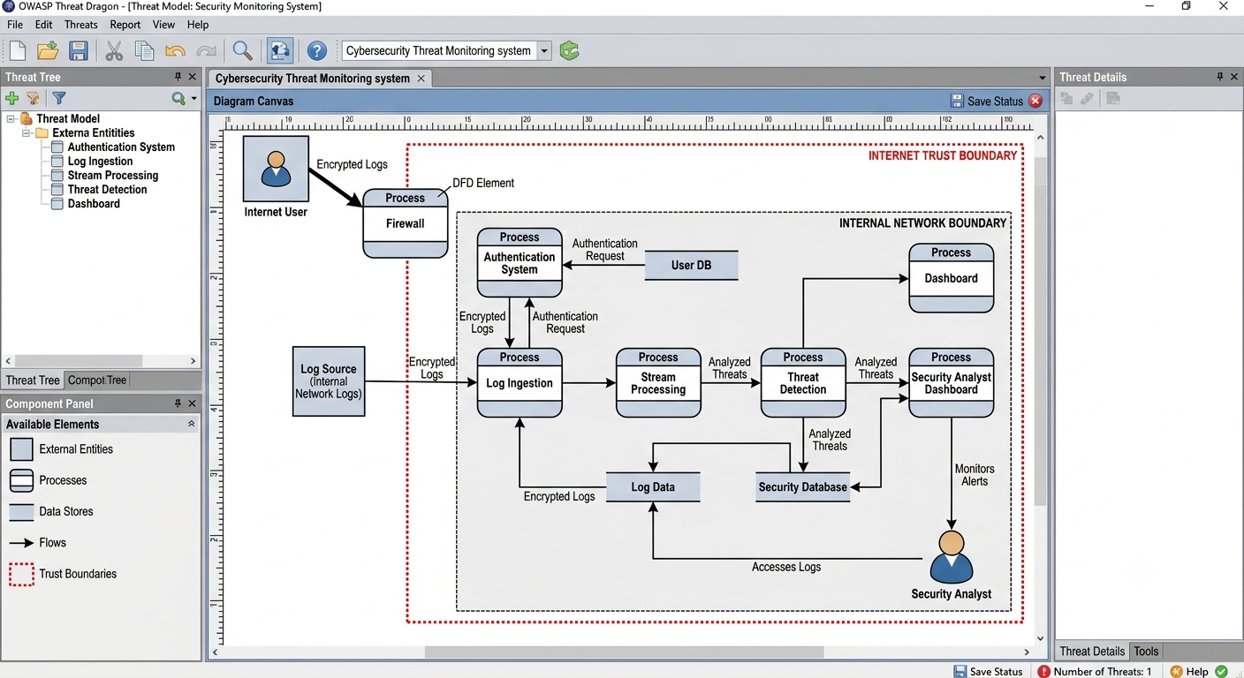

Guided Tool Module 4: Dashboard or Analytics Output Mockup
Purpose: Show how raw big data becomes useful decisions through a dashboard, alert, forecast, recommendation or report.
Beginner-Friendly Choice
Use any one: Power BI, Looker Studio, Tableau Public or Canva. If login/install is difficult, Canva dashboard mockup is acceptable. If data connection is possible, Power BI/Looker Studio/Tableau Public is stronger.
No. | Perform |  | Observe / Decide |  |  | Record in Workbook
1 | Prepare a small sample dataset in Excel or Google Sheets with 10-20 rows. |  | Columns should match your scenario. Example: timestamp, user/location, event type, value, status, risk level. |  |  | Paste column names.
2 | Choose the dashboard tool. |  | Power BI/Tableau/Looker are analytics tools; Canva is acceptable for visual mockup when live data connection is blocked. |  |  | Write chosen tool and reason.
3 | Import or recreate the sample data. |  | In Power BI/Looker/Tableau, connect data. In Canva, manually create charts from sample values. |  |  | Paste screenshot of data/chart setup.
4 | Create at least three visual elements. |  | Use KPI card, bar chart, line chart, table, map, alert count or pie/donut chart as appropriate. |  |  | List the visuals.
5 | Add decision labels. |  | A dashboard is useful only if it supports a decision: allocate beds, detect fraud, reroute buses, restock products, warn farmers. |  |  | Write decision supported by each visual.
6 | Export/share screenshot. |  | Paste the final dashboard screenshot or public/report link if available. |  |  | Paste evidence.
Dataset Column |  | Meaning |  |  | Example Value
Timestamp |  | When the security event was recorded |  |  | 2024-05-15 14:25:50
Source |  | IP address or host that generated the event |  |  | 45.2.112.9
Event Type |  | Category of security event detected |  |  | Malware Alert
Risk Level |  | Severity assigned to the event |  |  | Critical
Status |  | Current handling state of the event |  |  | Resolved
Department |  | Team responsible for the affected system |  |  | Network Operations
Visual Element |  | Metric Shown |  | Decision Supported
KPI card |  | Total security events (last 30 days) |  | Gauge overall alert volume trend
Line chart |  | Security events over time (daily) |  | Spot spikes that need investigation
Donut chart |  | Risk severity breakdown (Low/Medium/High/Critical) |  | Prioritize analyst attention toward Critical/High
Data table |  | Per-incident detail (timestamp, source, type, status) |  | Decide which specific incident to act on next

Dashboard / Analytics Output Evidence
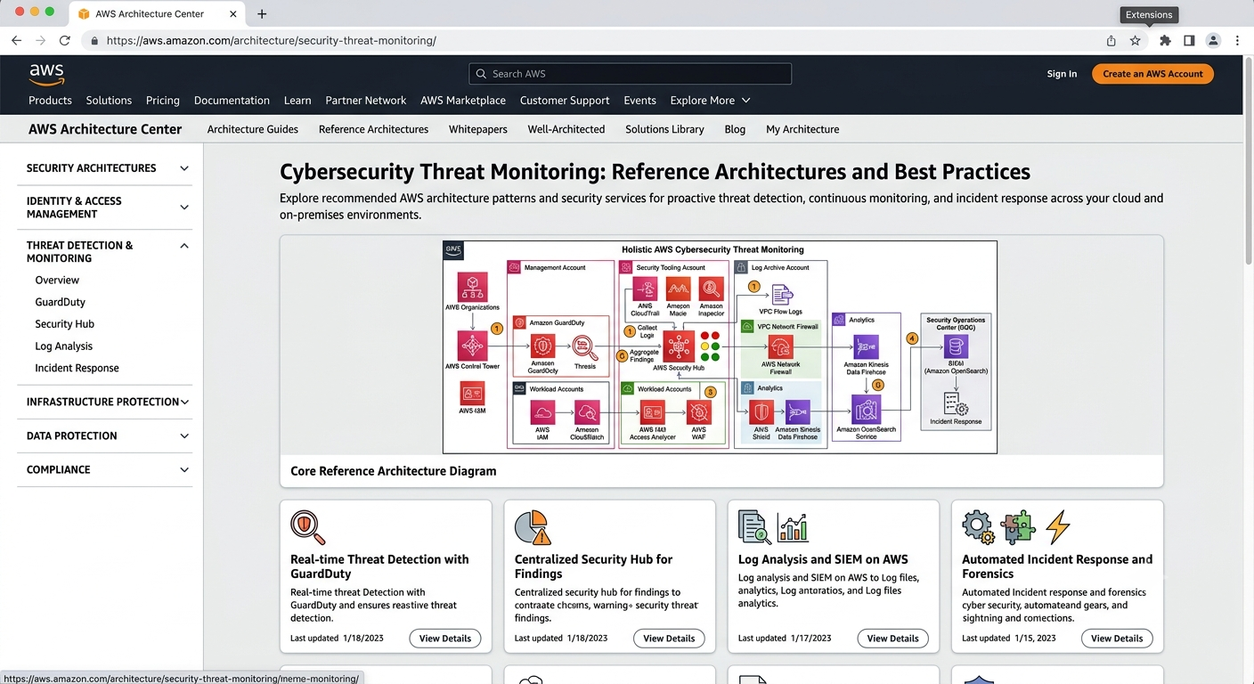

Final CO4 AT2 Solution Sections
Final Assembly
After completing the guided tool modules, combine the evidence into the final solution. The final answer must show technical reasoning, not only screenshots.

1. Problem Understanding
What to include: Identify stakeholders, decisions required, data produced, expected analytics output and urgency.

Student Response
Stakeholders: security analysts monitoring the SOC dashboard, IT/network administrators who own the firewalls and auth systems, and end users whose accounts may be compromised.
Decisions required: whether a login attempt or network event is malicious, whether to auto-block an IP or account, and which incidents need escalation to a human analyst.
Data produced: authentication logs, firewall alerts, API access logs, failed-login attempts and suspicious network events, arriving continuously from many systems.
Expected analytics output: a real-time risk dashboard showing event volume and severity, plus automated high-risk alerts routed to analysts.
Urgency: high - credential-stuffing or intrusion attempts must be flagged within seconds to minutes, not after a daily batch job, so the system needs a streaming-capable pipeline.

2. 5Vs Mapping
What to include: Map Volume, Velocity, Variety, Veracity and Value using scenario evidence.

Student Response
Volume: authentication and firewall logs from many systems generate a continuously growing set of records, easily reaching millions of events per day in a mid-size organization.
Velocity: failed logins and suspicious network events must be ingested and scored within seconds so an active attack can be blocked before it succeeds.
Variety: structured auth logs, semi-structured firewall/API JSON logs and unstructured alert notes all feed the same pipeline.
Veracity: false positives (a legitimate user mistyping a password) must be filtered from true threats, so validation against known-good IP/user lists matters.
Value: the pipeline is only useful if it shortens the time between an attack starting and an analyst being alerted - that reduction in response time is the measurable value.

3. Big Data Architecture
What to include: Paste final draw.io architecture showing sources, ingestion, storage, processing, analytics/security and users.

Student Response
[Paste your final draw.io architecture screenshot here: log sources -> ingestion -> storage -> stream/batch processing -> SIEM/analytics/dashboard -> security analyst, with a trust boundary around the cloud platform.]
Summary: sources (firewall, auth system, APIs) send logs into an ingestion service; a stream processor filters and windows events; results are written to both a fast analytics store and long-term object storage; a dashboard/SIEM layer surfaces alerts to the security analyst.

4. Data Flow Pipeline
What to include: Explain how raw data moves, gets cleaned, stored, processed and converted into dashboard/alert/decision.

Student Response
Raw logs are generated continuously by firewalls, the authentication system and API gateways.
These logs are pushed into an ingestion/streaming layer, which timestamps and validates each record and discards malformed entries.
A stream-processing job enriches each event (e.g. tagging known-bad IPs from a threat-intel feed) and aggregates counts in short time windows.
Enriched events are written to a fast analytics store for live queries and to object storage for long-term/batch analysis.
The analytics store feeds a SIEM dashboard that converts raw counts into a risk score, and any score above threshold becomes an automated alert routed to the security analyst for a decision.

5. Tool and Technology Justification
What to include: Use cloud architecture references and Hadoop/Spark documentation to justify chosen tools.

Student Response
Spark Structured Streaming is used for the live detection path because the same DataFrame API expresses both streaming and batch logic, reducing code duplication, and it natively supports the windowed aggregation needed for per-minute failed-login counts.
Hadoop/MapReduce-style batch processing is retained for the nightly trend job, since it is well suited to scanning large volumes of historical log data cheaply when latency does not matter.
A managed object store (S3/Blob/Cloud Storage category, per the architecture centers) holds raw and processed logs long-term at low cost, satisfying compliance retention needs.
A SIEM-style analytics/dashboard service (as shown in the AWS/Azure architecture references) was chosen over a plain BI tool because it has built-in threat-intelligence correlation, which a generic dashboard lacks.
This combination matches the official reference architectures' recommended pattern of ingestion, dual batch/stream processing, and a dedicated security analytics layer.

6. Security and Privacy Strategy
What to include: Use threat model output to explain threats and controls.

Student Response
Spoofing - an attacker could forge log source identity; mitigated by requiring authenticated log shippers so only verified sources can write into the ingestion layer.
Tampering - logs could be altered in transit or storage; mitigated by encrypting logs in transit and at rest and using write-once storage for the raw log archive.
Information disclosure - security logs are themselves sensitive; mitigated by role-based access control limiting who can query raw logs versus aggregated dashboards.
Denial of service - a flood of junk events could overwhelm ingestion; mitigated by rate limiting and auto-scaling the ingestion tier.
Elevation of privilege - a compromised service account could gain broader access than intended; mitigated by least-privilege IAM roles and regular access audits, consistent with STRIDE-based threat modeling.

7. Challenges and Solutions
What to include: Write at least four big-data implementation challenges and one practical solution for each.

Student Response
Challenge 1: Alert fatigue from too many low-value alerts - Solution: tune thresholds and add a severity-scoring step so only high-confidence incidents reach analysts.
Challenge 2: High log volume increasing storage and processing cost - Solution: tier storage (hot analytics store for recent data, cheap object storage for older logs) and aggregate before long-term storage.
Challenge 3: False positives from legitimate but unusual user behavior - Solution: maintain a baseline per user/IP range and only alert on deviations from that baseline.
Challenge 4: Keeping the streaming pipeline available during traffic spikes - Solution: use auto-scaling stream processing and a durable message queue as a buffer so no events are dropped.

8. Business Outcome
What to include: State measurable outcome: faster decision, reduced fraud, lower waiting time, improved prediction, lower downtime or better user experience.

Student Response
Faster decision-making: the security team moves from discovering intrusions during a periodic manual log review to detecting suspicious activity within minutes of it happening.
Reduced risk exposure: automated correlation against threat-intel feeds lowers the chance a genuine attack is missed among routine log noise.
Lower analyst workload: aggregation and severity scoring mean analysts review a short prioritized alert list instead of raw logs.
For CrowdCare specifically, the same streaming-detection pattern would let the platform flag anomalous incident-reporting patterns (e.g. spoofed sensor data) with the same speed.

Rubric
Criteria | Marks | Evaluation Focus | Evidence
Problem and 5Vs analysis | 6 | Scenario-specific analysis and correct big-data reasoning | Workbook tables
Architecture and data flow | 6 | Correct pipeline, cloud components and flow clarity | draw.io diagram
Processing framework decision | 5 | Batch/streaming/hybrid justification using Hadoop/Spark concepts | Decision table
Security and privacy | 5 | Threat model, risks and controls | Threat model table/screenshot
Dashboard/output design | 4 | Useful decision-oriented analytics output | Dashboard/mockup
Clarity and submission quality | 4 | Organized, original, complete evidence | GitHub/GCR

Submission Checklist
- Student details and selected scenario are filled.
- Cloud architecture references are recorded.
- Hadoop/Spark processing decision is completed.
- Threat model diagram/table is included.
- Dashboard/mockup screenshot or link is included.
- Final solution sections are completed.
- DOCX/PDF and supporting files are uploaded to GitHub.
- GitHub repository link is submitted through Google Classroom.

Official Reference Links
AWS Architecture Center: https://aws.amazon.com/architecture/
Azure Architecture Center: https://learn.microsoft.com/en-us/azure/architecture/
Google Cloud Architecture Center: https://docs.cloud.google.com/architecture
Apache Hadoop MapReduce Tutorial: https://hadoop.apache.org/docs/stable/hadoop-mapreduce-client/hadoop-mapreduce-client-core/MapReduceTutorial.html
Apache Spark Structured Streaming: https://spark.apache.org/docs/latest/streaming/index.html
Microsoft Threat Modeling Tool releases: https://learn.microsoft.com/en-us/azure/security/develop/threat-modeling-tool-releases
OWASP Threat Dragon: https://owasp.org/www-project-threat-dragon/
Power BI documentation: https://learn.microsoft.com/en-us/power-bi/
Looker Studio create report: https://docs.cloud.google.com/data-studio/create-a-report
Tableau Public: https://www.tableau.com/community/public
Canva Charts: https://www.canva.com/help/charts/

